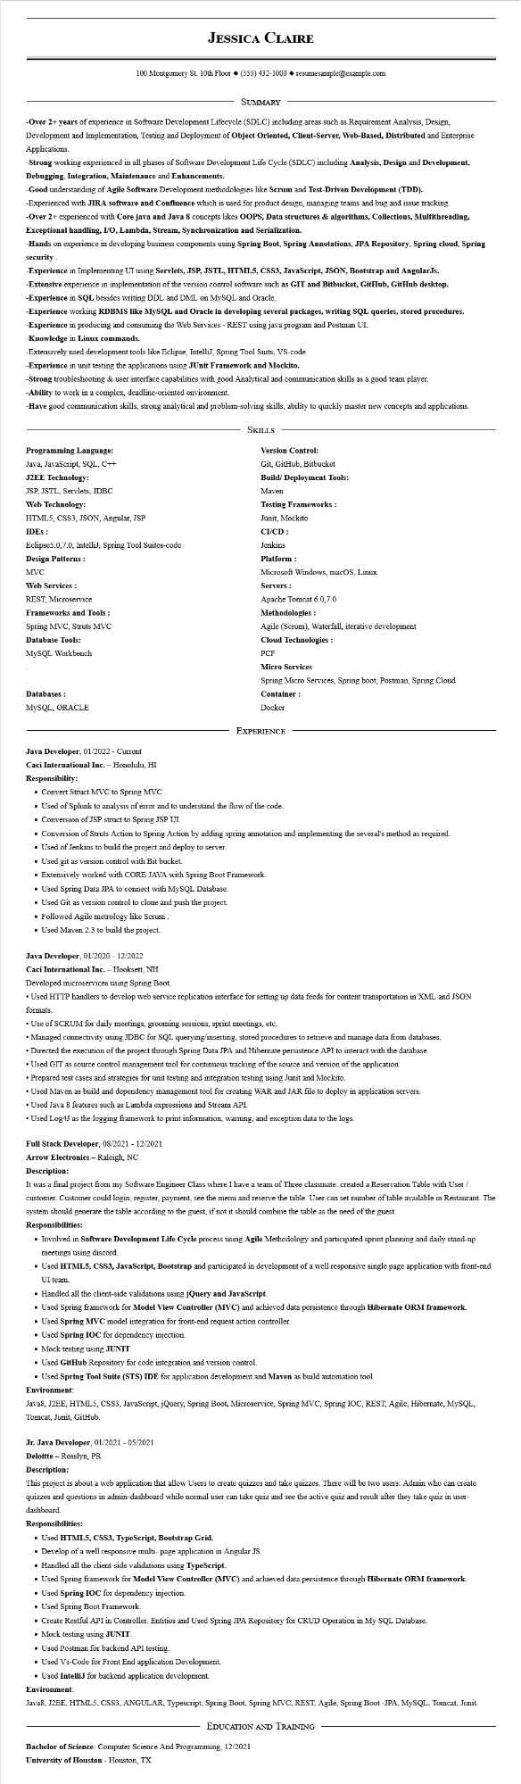
JESSICA CLAIRE
100 Montgomery St. 10th Floor (555) 432-1000◆ resumesample@example.com
SUMMARY
-Over 2+ years of experience in Software Development Lifecycle (SDLC) including areas such as Requirement Analysis, Design, Development and Implementation, Testing and Deployment of Object Oriented, Client-Server, Web-Based, Distributed and Enterprise Applications.
-Strong working experienced in all phases of Software Development Life Cycle (SDLC) including Analysis, Design and Development, Debugging, Integration, Maintenance and Enhancements.
-Good understanding of Agile Software Development methodologies like Scrum and Test-Driven Development (TDD). -Experienced with JIRA software and Confluence which is used for product design, managing teams and bug and issue tracking. -Over 2+ experienced with Core java and Java 8 concepts likes OOPS, Data structures & algorithms, Collections, Multithreading, Exceptional handling, I/O, Lambda, Stream, Synchronization and Serialization.
-Hands on experience in developing business components using Spring Boot, Spring Annotations, JPA Repository, Spring cloud, Spring security
-Experience in Implementing UI using Servlets, JSP, JSTL, HTML5, CSS3, JavaScript, JSON, Bootstrap and AngularJs. -Extensive experience in implementation of the version control software such as GIT and Bitbucket, GitHub, GitHub desktop. -Experience in SQL besides writing DDL and DML on MySQL and Oracle.
-Experience working RDBMS like MySQL and Oracle in developing several packages, writing SQL queries, stored procedures. -Experience in producing and consuming the Web Services - REST using java program and Postman UI.
-Knowledge in Linux commands.
-Extensively used development tools like Eclipse, IntelliJ, Spring Tool Suits, VS-code.
-Experience in unit testing the applications using JUnit Framework and Mockito.
-Strong troubleshooting & user interface capabilities with good Analytical and communication skills as a good team player.
-Ability to work in a complex, deadline-oriented environment.
-Have good communication skills, strong analytical and problem-solving skills, ability to quickly master new concepts and applications.
Programming Language:
Java, JavaScript, SQL, C++
J2EE Technology:
JSP, JSTL, Servlets, JDBC
Web Technology:
HTML5, CSS3, JSON, Angular, JSP
IDEs:
Eclipse 5.0,7.0, IntelliJ, Spring Tool Suites-code
Design Patterns:
MVC
Web Services :
REST, Microservice
Frameworks and Tools :
Spring MVC, Struts MVC
Database Tools:
MySQL Workbench
Databases:
MySQL, ORACLE
Java Developer, 01/2022 - Current
SKILLS
Version Control:
Git, GitHub, Bitbucket
Build/Deployment Tools:
Maven
Testing Frameworks:
Junit, Mockito
CI/CD :
Jenkins
Platform:
Microsoft Windows, macOS, Linux
Servers :
Apache Tomcat 6.0.7.0
Methodologies :
Agile (Scrum), Waterfall, iterative development
Cloud Technologies:
PCF
Micro Services
Spring Micro Services, Spring boot, Postman, Spring Cloud
Container:
Docker
EXPERIENCE
Caci International Inc. - Honolulu, HI
Responsibility:
• Convert Struct MVC to Spring MVC.
• Used of Splunk to analysis of error and to understand the flow of the code.
• Conversion of JSP struct to Spring JSP UI
• Conversion of Struts Action to Spring Action by adding spring annotation and implementing the several's method as required.
• Used of Jenkins to build the project and deploy to server.
• Used git as version control with Bit bucket.
• Extensively worked with CORE JAVA with Spring Boot Framework.
• Used Spring Data JPA to connect with MySQL Database.
• Used Git as version control to clone and push the project.
• Followed Agile metrology like Scrum
• Used Maven 2.3 to build the project.
Java Developer, 01/2020 - 12/2022
Caci International Inc. - Hooksett, NH
Developed microservices using Spring Boot.
• Used HTTP handlers to develop web service replication interface for setting up data feeds for content transportation in XML and JSON formats.
• Use of SCRUM for daily meetings, grooming sessions, sprint meetings, etc.
• Managed connectivity using JDBC for SQL querying/inserting, stored procedures to retrieve and manage data from databases.
• Directed the execution of the project through Spring Data JPA and Hibernate persistence API to interact with the database
• Used GIT as source control management tool for continuous tracking of the source and version of the application.
• Prepared test cases and strategies for unit testing and integration testing using Junit and Mockito.
• Used Maven as build and dependency management tool for creating WAR and JAR file to deploy in application servers.
• Used Java 8 features such as Lambda expressions and Stream API.
• Used Log4J as the logging framework to print information, warning, and exception data to the logs.
Full Stack Developer, 08/2021 - 12/2021
Arrow Electronics - Raleigh, NC
Description:
It was a final project from my Software Engineer Class where I have a team of Three classmate: created a Reservation Table with User / customer. Customer could login, register, payment, see the menu and reserve the table. User can set number of table available in Restaurant. The system should generate the table according to the guest, if not it should combine the table as the need of the guest.
Responsibilities:
• Involved in Software Development Life Cycle process using Agile Methodology and participated sprint planning and daily stand-up meetings using discord.
• Used HTML5, CSS3, JavaScript, Bootstrap and participated in development of a well responsive single page application with front-end
UI team.
• Handled all the client-side validations using jQuery and JavaScript.
• Used Spring framework for Model View Controller (MVC) and achieved data persistence through Hibernate ORM framework.
• Used Spring MVC model integration for front-end request action controller.
• Used Spring IOC for dependency injection.
• Mock testing using JUNIT.
• Used GitHub Repository for code integration and version control.
• Used Spring Tool Suite (STS) IDE for application development and Maven as build automation tool
Environment:
Java8, J2EE, HTML5, CSS3, JavaScript, jQuery, Spring Boot, Microservice, Spring MVC, Spring IOC, REST, Agile, Hibernate, MySQL, Tomcat, Junit, GitHub.
Jr. Java Developer, 01/2021 - 05/2021
Deloitte - Rosslyn, PR
Description:
This project is about a web application that allow Users to create quizzes and take quizzes. There will be two users: Admin who can create quizzes and questions in admin-dashboard while normal user can take quiz and see the active quiz and result after they take quiz in user-
dashboard.
Responsibilities:
• Used HTML5, CSS3, TypeScript, Bootstrap Grid.
• Develop of a well responsive multi-page application in Angular JS.
Handled all the client-side validations using TypeScript.
• Used Spring framework for Model View Controller (MVC) and achieved data persistence through Hibernate ORM framework.
• Used Spring IOC for dependency injection.
• Used Spring Boot Framework.
• Create Restful API in Controller. Entities and Used Spring JPA Repository for CRUD Operation in My SQL Database.
• Mock testing using JUNIT.
• Used Postman for backend API testing.
• Used Vs-Code for Front End application Development.
• Used IntelliJ for backend application development.
Environment:
Java8, J2EE, HTML5, CSS3, ANGULAR, Typescript, Spring Boot, Spring MVC, REST, Agile, Spring Boot -JPA, MySQL, Tomcat, Junit.
EDUCATION AND TRAINING
Bachelor of Science: Computer Science And Programming, 12/2021
University of Houston - Houston, TX

